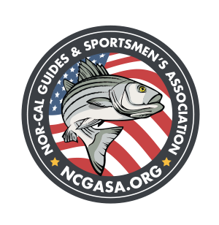
NCGASA DONATION FORM

Mail checks to 1771 Wildflower Circle, Yuba City, CA 95993, Attn: NCGASA Board Treasurer
Aimee Ferguson. For questions: (530) 588-5513 or email: AFerguson@ncgasa.org

Donation Amount: $__________________
$30 General Membership, $50 Guide Membership, $75 Family Membership, $100 Business Membership
$250 Business Sponson, $500 Lifetime Membership, $1,000 Lifetime Business Membership or Other. Other: if you would like your donation to go to a river clean up or a cause or an event.

Other Donation Description: ___________________________________________________________________
____________________________________________________________________________

Sticker you would like to receive for your donation: (Circle One)

SALMON, STEELHEAD, STRIPED BASS, STURGEON, DEER, DUCK, GOOSE, LARGEMOUTH BASS, OR RAINBOW TROUT

Company Name: _____________________________________________________________

Your Name: _________________________________________________________________

Cell Phone Number: __________________________________________________________

Mailing Address: ____________________________________________________________ City _____________________
State ______ Zip Code ____________

Email Address: _____________________________________________________________________________________

NCGASA IS A 501 (c)(3) nonprofit organization. Thank you for your donation! We can send you our Federal Tax ID number upon request.

